Parkdale PE Update September 2023

Welcome back to a new year, and to those of you new to Parkdale, welcome to our wonderful community!

Lots has been happening behind the scenes in our PE department over the last year and we thought it would be a good time to let you know about some recent developments. I, Mrs Rippon, am the new PE Lead, supported, as always, by Miss Baker and Mr Hillier. Everyone at Parkdale is passionate about PE as integral part of school life, offering children the opportunity to develop and excel, get and keep fit, play in teams and learn new sports.

Firstly, I would love to hear about the sporting activities and achievements of your children outside school. I will be displaying our sporting superstars on our PE display and celebrating their fabulous achievements with our whole school. Parents this applies to you too! We know some of you are successful athletes in your own right and we would love to share your stories with our children. Please email any photos, details and achievements to me hrippon@parkdale.notts.sch.uk We would also love to celebrate swimming badges, medals won, etc in our weekly Values Champion assemblies so please send details of these to class teachers by Friday 9am.

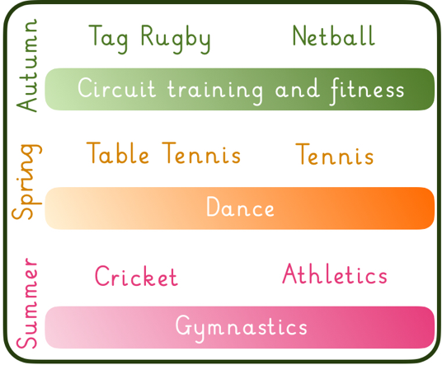
Secondly, I thought you may be interested to hear how our curriculum has evolved. We have been working with our children and teachers to ensure that children are developing the skills and knowledge to access and play competitive games in PE, as well as developing core agility, balance and physical fitness. We decided to focus on key sports that would enable more children to participate and, by focusing on specific sports and progressing our skills, allow us to focus on games and competitions in PE lessons by upper KS2. Each term we focus upon two key sports, one hour each a week. We will also incorporate a fitness/agility activity ongoing throughout each term, that ensures all children develop these key skills. The eagle eyed among you may notice that football isn’t on the list, this is simply because we offer football clubs, football training and football is accessible at break. We remain committed to football and continuing the success of our teams.

Tournaments and House competitions will happen each term, in either of the focus sports, including every child. This is in addition to the various Transform and Gedling competitions that we enter. Hopefully, this will give children a real goal to aim for in their lessons, knowing that they will be competing for their house and earning some house points. Perhaps they will even be inspired to join sports clubs outside of school?

PE trips and visits will be increasing! After COVID these were, unfortunately, less frequent. However, we have reached out to local teams and requested that we restart as many opportunities as we can. If you have any contacts with local sports clubs, please don’t hesitate to share them with us! Our events calendar will display any activities as they are booked in.

New events on the horizon include:
- Cycling days to rollout to KS1 after a hugely successful few years in Reception
- Swimming to have a major, exciting refresh
- Swimming trips hopefully happening soon (awaiting leisure centre confirmation)
- Boccia
- And of course in the summer we will be holding special events and lessons to celebrate the Olympics!

Finally, thank you for all of your support. Please let us know if you have any suggestions.

Hayley Rippon
Parkdale PE Lead

