|  |  |
| --- | --- |
| SPEECH & LANGUAGE  SUPPORT IN SCHOOL |  |
| |  | | --- | |  | |  |
| Talk, Learn & Communicate  Speech & Language Services for Schools and Settings |  |





**What is Speech and Language**

**Therapy?**

Speech & language therapists work with children to help them communicate to the best of their ability.

Holly Harris is our Speech & language therapist in school and works with children to see if they would benefit from extra support.

**What does this mean?**

If you or your child’s teacher have concerns or notice that your child is having difficulties with their:

* speech
* language and/or
* communication skills

You will be asked to sign a consent form for Holly to work with your child in school.

The Communication Pyramid shows how communication is a complex skill that grows and develops over time. It is important that children develop firm foundations of earlier skills at the bottom of the pyramid so they can successfully develop later skills towards the top.

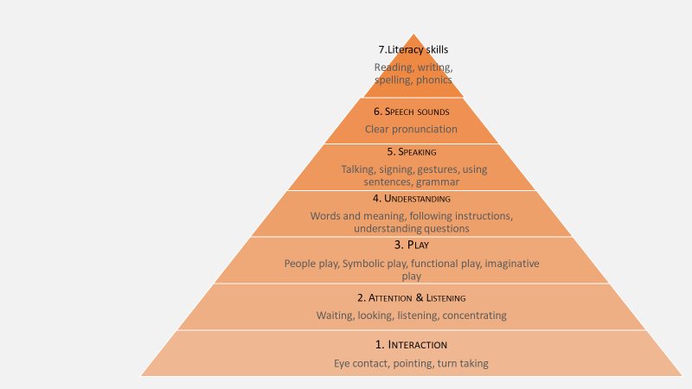

**The Communication Pyramid**



**What are speech, language and communication skills?**

**Speech = sounds and pronunciation**

* Involves the individual sounds used to make up words, saying sounds accurately and in the right places
* Speaking fluently without hesitating too much, or without repeating sounds or words
* Speaking clearly with expression and using appropriate pitch, volume, and intonation to give meaning.

**Language = understanding and using words and sentences**

Before we can use language, we must understand it.

* Processing and understanding what people say
* Understanding spoken words and sentences
* Following instructions
* Understanding the rules of grammar being used
* Using words (vocabulary) to label and describe objects, actions, and attributes
* Using words to build sentences
* Using sentences to build stories and conversations.



**Communication = social skills and interaction**

* Involves how language is used to interact with others
* Includes non-verbal communication such as looking, listening, using facial expression and gestures effectively and taking conversational turns
* Using language in different ways to suit the situation
* Being able to consider other people’s point of view

**Why is this important?**

**Children need strong communication skills for all areas of life, it is the foundation of relationships, learning, play and social interaction.**

**Learning** - It is difficult for children to learn and understand new information if they find it hard to listen, understand and talk.

**Literacy** - Children with speech and language needs are at a higher risk of difficulties with their reading, writing, and spelling.

**Confidence** - Children need good communication skills to help their and confidence and to make friends

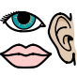

**Communication = social skills and interaction**

Involves how language is used to interact with others

* Includes non-verbal communication such as looking, listening, using facial expression and gestures effectively and taking conversational turns
* Using language in different ways to suit the situation
* Being able to consider other people’s point of view.

**Why is this important?**

**Children need strong communication skills for all areas of life, it is the foundation of relationships, learning, play and social interaction.**

**Learning** - It is difficult for children to learn and understand new information if they find it hard to listen, understand and talk.

**Literacy** - Children with speech and language needs are at a higher risk of difficulties with their reading, writing, and spelling.

**Confidence** - Children need good communication skills to support their confidence. This will help them to join in with others and make friends.

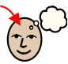





**What will the Speech and Language therapist do?**

**Assessment**

Assessment of your child’s needs will take place to decide what your child needs support with. This may include:

* Observation in class and informal assessments
* Talking to teaching staff and other professionals
* Talking to you and your child
* Formal assessment

**Setting goals**

Following assessment, a decision will be made about appropriate goals and intervention for your child. These will be shared with you and teaching staff.

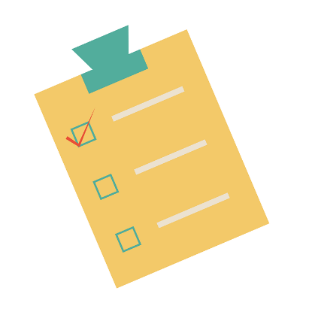

**Intervention**

The Speech & language therapist can support your child’s communication needs in some of the following ways:

* preparing programmes of intervention
* working with teaching staff and other professionals
* supporting staff and parents/carers to carry out intervention programmes
* providing training to staff supporting your child
* working with staff to implement classroom strategies
* working individually with your child
* working with your child as part of a group
* referral to NHS services for ongoing or specialist support

Depending on the nature of your child’s difficulties, they may not need to receive direct intervention from the Speech & language therapist. They will be supported in different ways in school which will be overseen by the Speech & language therapist.

|  |  |
| --- | --- |
| SPEECH & LANGUAGE  SUPPORT IN SCHOOL |  |
| |  | | --- | |  | |  |
| Talk, Learn & Communicate  Speech & Language Services for Schools and Settings |  |



**What is the role of the parent?**

**It is important that you are aware and involved with your child’s speech and language targets. We must work together for your child to reach their goal.**

* Practise the activities provided by the Speech & language therapist as often as you can. Little and often is best, just 5-10 minutes every day can make more difference than a big session just once a week.
* Take opportunities to speak with or meet the Speech & language therapist to keep up to date with your child’s targets and progress and best ways to support your child at home.





**How can I help at home?**

* **Help your child to listen** – by turning off background noise and distractions when talking and playing.
* **Say their name**- this helps to get their attention.
* **Give them time** – some children need up to 10 seconds to think about what you have said and come up with an answer.
* **Listen to what your child is saying** rather than how they say it and repeat words back the right way - this helps children to hear the right sounds in the word even if they can’t say them yet.
* **Be careful with how many questions** you ask - too many can make it feel like a test. Instead make it a conversation, and comment on what your child is doing or what is happening.
* **Use positive instructions** – instead of telling your child what you DON’T want them to do, try telling them what you DO want them to do! e.g. change ‘stop running’ into ‘walk carefully please’.
* **Have Special Time** – dedicate just 10 minutes a day where you and child spend time together doing an activity. Give your child your full attention, listen and focus on what they say and have some fun!



**Find out more – information & resources**

[www.ican.org.uk](http://www.ican.org.uk)

[www.booktrust.org.uk](http://www.booktrust.org.uk)

[www.literacytrust.org.uk](http://www.literacytrust.org.uk)

[www.makaton.org](http://www.makaton.org)

**Local services**

Nottinghamshire Healthcare NHS Children's Speech and Language Therapy Service

Tel: [0300 123 3387](tel:0300%20123%203387)

[www.nottinghamshirehealthcare.nhs.uk/childrens-slt-resources](http://www.nottinghamshirehealthcare.nhs.uk/childrens-slt-resources)

**NOTES**

**……………………………………………………………………………………………………………………………………………………………………………………………………………………………………………………………………………………………………………………………………………………………………………………………………………………………………………………………………………………………………………………………………………………………………………………………………………………………………………………………………………………………………………………………………………………………………………………………………………………………………………………………………………………………………………………………………………………………………………………………………………………………………………………………………………………………………………………………………………………………………………………………………………………………………………………………………………………………………………………………………………………………………………………………………………………………………………………………………………………………………………………………………………………………………………………………………………………………………………………………………………………………………………………………………………………………………………………………………………………………………………………………………………………………………………………………………………………………………………………………….**

## ***Hello!***

## ***I’m Holly Harris,***

## ***Speech & language therapist at***

## ***Parkdale Primary School.***

## **I am in school every Thursday.**

***If you would like to chat to me about your child’s communication, you can speak to a member of staff to arrange this.***

