List 26 - The /s/ sound spelled c  Summer term - The date written is the date when the spellings are given out. There will be a test the following Thursday. .Thursday.  21.4.22  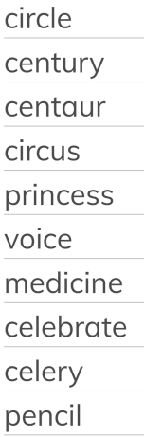 | List 27 - Word families (real and sol)  28.4.22  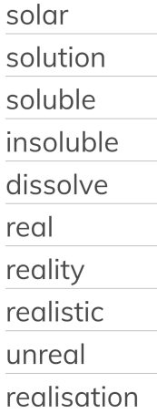 | List 28 - Word families (phon and sign)  5.5.22  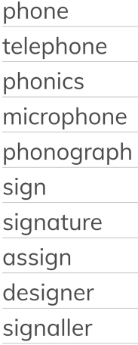 | List 29 - Prefixes super- anti- and auto-  12.5.22  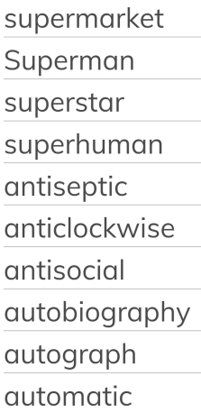
List 30 - The prefix bi-  19.5.22  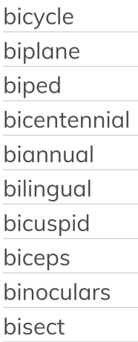 | List 31 - Challenge words  26.5.22  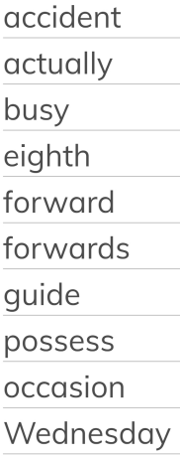 | List 32 - Plural possessive apostrophes  2.6.22 (over half term)  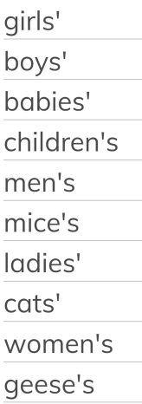 | Revision  9.6.22  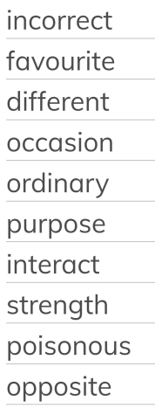
Revision  16.6.22  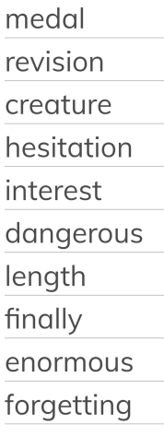 | List 33 - Revision 23.6.22  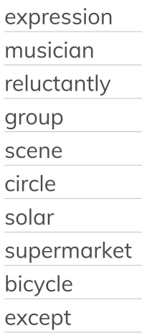  Spellings can also be found on Spelling Shed. | List 34- Revision  30.6.22  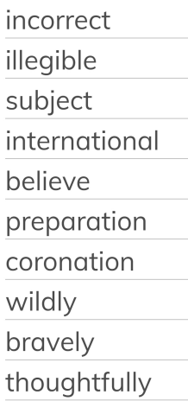 | List 35 - Revision  7.7.22  